*PEEB4*

Project Earth Energy Balance

Purpose: *To develop a quantitative understanding of the temperature of the Earth, the effect of the atmosphere on the surface temperature, the anthropogenic impact on the atmosphere, and how the surface temperature can be controlled – either warmer or cooler – by atmospheric modification.*

**A Single Layer Model of the Atmosphere**

In PEEB3 we calculated an anthropogenic CO2 annul interest rate of 0.82% given a 2015 carbon footprint of 4 tons per person:

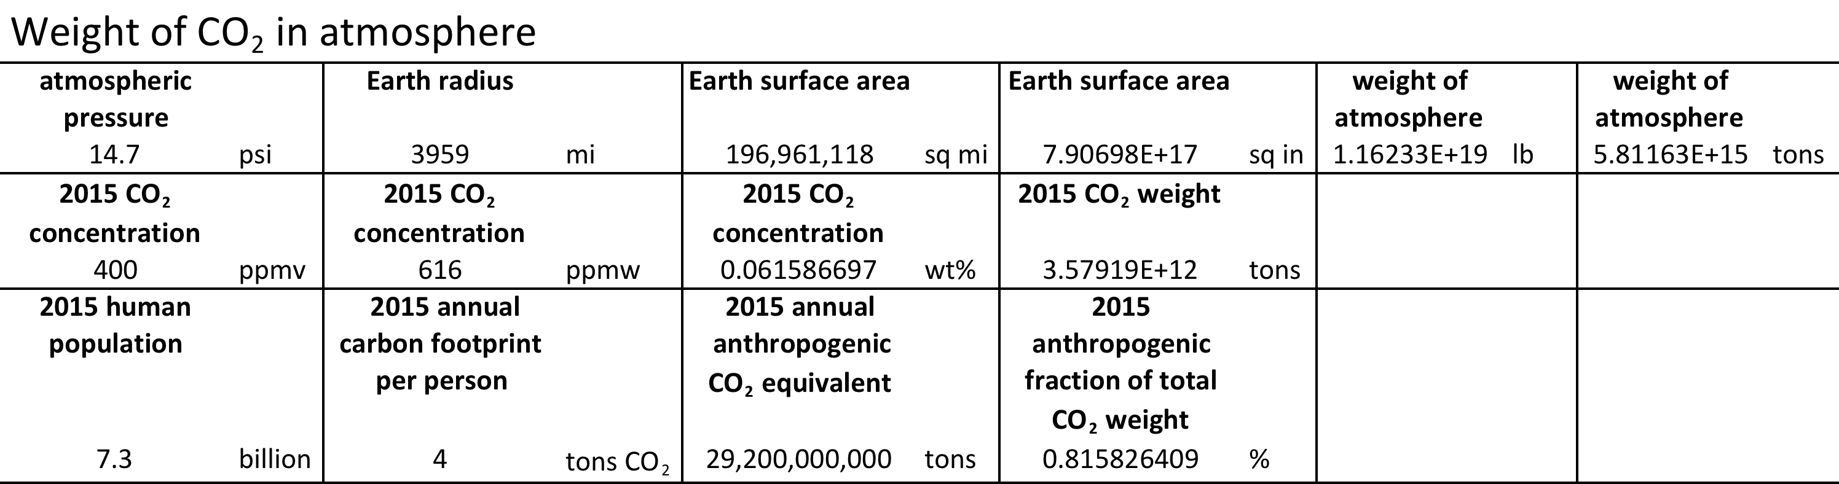

We also calculated the CO2 weight gain between 1750 (280 ppmv) and 2015 (400 ppmv) of 1.07 x 1012 tons, which, *even on a crash diet of zero CO2 emissions from all sources and zero population growth*, would take between 74 and 294 years to lose, assuming nature’s absorption capacity to be between 2 tons and ½ ton, respectively.



Finally, using the compound interest formula, we calculated an *average* CO2 interest rate since 1900 of 0.31%. Assuming a constant interest rate of 0.82% going forward, we projected a compounding factor of 1.2 over the next 20 years, or 1.5 over the next 50 years.



The 50-year compounding factor of 1.50 would result in a CO2 concentration of 400 x 1.5 = 600 ppmv, more than twice the pre-industrial level of 280 ppmv. This is not a prediction, rather a projection, based on clearly stated assumptions.

Anthropogenic CO2 has been produced primarily by the combustion of crude oil distillates, coal, and natural gas, and by deforestation. For example, gasoline for the transportation sector, consisting primarily of hexane C6H14, reacts with oxygen in the atmosphere to form CO2 and water vapor:

2C6H14 + 19O2 ➔ 12CO2 + 14H2O + energy

Each C6H14 molecule, with an atomic weight of 86, produces six CO2 molecules, with a total atomic weight of 6 • 44 = 264. In other words, one pound of gasoline produces 264/86 ≈ 3.1 pounds of CO2. Or, one gallon of gasoline, weighting 6.3 pounds, produces about 6.3 x 3.1 ≈ 20 pounds of CO2. Here is one easy-to-remember result: an SUV getting 20 miles to the gallon produces about one pound of CO2 per mile.

1 gal gasoline ➔ 20 lbs CO2

SUV ≈ 1 lb CO2 per mile

Earth’s CO2 weight gain since 1750 of 1.07 • 1012 tons = 2.14 • 1015 pounds is thus the equivalent of (2.14 • 1015) / 20 = 1.07 •1014 gallons, or 97.3 cubic miles of gasoline (1 gal ≈ 231 cubic inches; 1 cubic mile = 2.54 x 1014 cubic inches = 1.10 x 1012 gal); this is the volume of gasoline which by itself, when oxidized by combustion, would produce the observed CO2 weight gain:

97 cubic miles of gasoline ➔ CO2 weight gain

To give this perspective, this is roughly the volume of Lake Erie, or three Lake Tahoes, filled with gasoline and set ablaze.

Coal has about the same carbon content per unit volume as gasoline. A similar back-of-the-envelope calculation for coal, still the largest source of energy for the generation of electricity worldwide, yields a similar result. The equivalent volume of coal, which by itself, when oxidized by combustion, would produce the observed CO2 weight gain, is about 99 cubic miles (assuming a density of 50 lbs per cubic foot and a carbon content of 80%):

99 cubic miles of coal ➔ CO2 weight gain

Thus the observed CO2 weight gain is roughly the equivalent of a combined 100 cubic miles of gasoline and coal after combustion. The injection of CO2 into the atmosphere has been straightforward given readily available and highly concentrated hydrocarbon sources in the form of crude oil and coal, plus an abundant supply of oxygen in the atmosphere. Note that natural gas, although cleaner than coal regarding pollutants, does nothing to change the equation for CO2 emissions. The burning of fossil fuels is, in the most literal sense of the word, an addiction:

*addiction* - the persistent, compulsive, and habit-forming use of a substance known by the user to be harmful, characterized by well-defined symptoms upon withdrawal.

Our current administration proudly touts the ascension of the US to the number one position among oil producers, topping even Saudi Arabia and Russia. Withdrawal, the abrupt cessation of this addiction, would in many cases be economic suicide. The temptation to burn fossil fuels has proven to be and continues to be irresistible. In 2015, Earth’s CO2 weight gain of 2.92 • 1010 tons, calculated in PEEB3, is the equivalent of 2.7 cubic miles of combusted gasoline and coal. Because it is so convenient, the burning of fossil fuels goes on, largely unabated, on a global scale.

On the other hand, removal of CO2 from the atmosphere, once it has dispersed over a tropospheric (the lower part of the atmosphere, about 7 miles thick) volume of more than 109 cubic miles, is anything but straightforward. It is easy to imagine that enhanced CO2 will be with us on *at least* the millennium time scale.

Culture, as it has developed in the Western world, can in a very real sense be expressed by the simple equation

culture = energy x technology,

to the extent that energy and technology are put to constructive use. “Advanced” civilizations throughout history can virtually be rank ordered by the per capita consumption of energy, from the domestication of animals and the harvesting of wind power to the burning of fossil fuels, each representing a quantum leap in human capacity to do work, travel vast distances, and live more comfortably.

To be sure, energy from the sun is truly abundant. A single solar array about 100 miles x 100 miles square in the Arizona desert could supply all the electricity needs of the United States, ignoring the problems of transmission and storage. Here is an easy to remember benchmark: at midday, a solar array the size of Phoenix – about (24 mile)2 – can meet the total electricity needs of the US: (24 mile)2 x (0.78 109 W/mi2) = 449 x 109 W or ~0.5 TW. Assuming a means of storing and transmitting electricity, an array (100 mile)2 could power the country day and night. The transition to renewable energy can and must take place, but it will take time.

Compounding the problem is population growth. World population is about 7.4 billion after having passed the 7 billion mark in 2011. Developing countries accounted for 97 percent of this growth with high birth rates and young average age. The population of Nigeria, for example, is projected to exceed that of the US by mid-century. Conversely, in developed countries the annual number of births barely exceeds deaths with associated low birth rates and much older populations. By 2025, it is likely that deaths will exceed births in the developed countries, the first time this will have happened in history.

It can be argued that population is the root cause of global warming, and that continued use of fossil fuels to accelerate the transition to developed nation status, especially in Africa and the Asian sub-continent, is a more sensible tradeoff than keeping fossil fuels in the ground to curtail CO2 emissions, which undoubtedly would delay economic transition and prolong population growth.

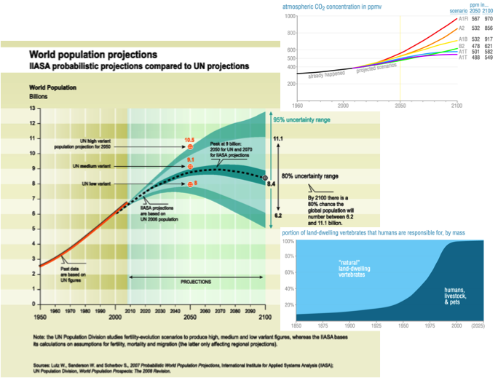

Projections for world population and atmospheric CO2 concentration in 2100. Note that all but the most optimistic projections for CO2 reduction predict more than a doubling of the pre-industrial level of 280 ppm by 2100.

**How atmospheric warming works - a single layer model of the atmosphere**

Most of us have little knowledge or intuition about the behavior of low-temperature black bodies* like Earth. The radiation they emit is invisible and we have essentially no direct experience of phenomena related to their properties. It will require extra effort to develop a sense of how the model works.

This model is based on the concept of emissivity of thermal radiation from a body (solid, liquid, or gas) at any temperature above zero Kelvin. The emissivity ε at a specified wavelength is the ratio of the amount of energy emitted by the body to the amount of energy emitted by a black body at the same temperature. Emissivities range from 0 (no emission) to 1 (for a black body).

A body with an emissivity less than unity and the same at all wavelengths is called a grey body, by comparison with a black body that has unit emissivity at all wavelengths. The total energy emitted by a grey body is equal to the energy emitted by a black body at the same temperature multiplied by the emissivity, that is, εσT4, where σ is the Stefan-Boltzmann constant, 5.67·10–8 W·m–2·K–4.  Aerosol particulate matter suspended in the atmosphere is a pretty good approximation of a grey body.

Grey bodies, like black bodies, absorb electromagnetic radiation. The absorptivity of a grey body is the ratio of the amount of energy absorbed by the body to the amount of energy absorbed by a black body at the same temperature. The definition of the absorptivity is parallel to the definition of emissivity. If the components of a grey body, the particles and molecules in a sample of an atmospheric aerosol, for example, are in thermal equilibrium, then the emissivity and absorptivity for thermal radiation must be equal. If the emissivity and absorptivity were not the same, the sample could spontaneously develop cooler and warmer regions, which violates the second law of thermodynamics.* Since the emissivity and absorptivity are the same for a grey body in thermal equilibrium, we use the same symbol, ε, for both, and begin to define a single-layer model for the atmospheric warming mechanism:

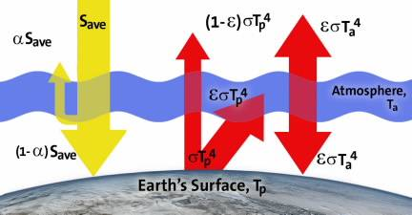

The energy from the sun that the surface absorbs is given by (1 – α)Save, where Save is the average incoming solar energy per unit area for Earth, 342 W·m–2, and α is Earth’s average albedo, 0.30, which accounts for the fraction of the total incoming radiation that is reflected away. The warmed surface emits radiation as a black body at a temperature of Tp. The total energy emitted is σTp4.

In this model, the atmosphere is represented by a single homogeneous layer of gases in thermal equilibrium at temperature Ta, acting as a grey body with an emissivity and an absorptivity given by ε. The atmosphere absorbs part of the energy emitted by the warmed surface. The amount of energy absorbed, εσTp4, is governed by the atmospheric absorptivity. The remainder of the radiation from the surface, (1 – ε)σTp4, passes unabsorbed through the atmosphere and into space. A grey body, like a black body, emits in all directions. This is represented in the figure by atmospheric emission both in toward the surface and out into space, the amount emitted in any direction given by the expression for emission from a grey body, εσTa4.

In steady state when the temperatures are constant, incoming solar radiation energy absorbed by the Earth is balanced by outgoing radiation from the surface and atmosphere:

(incoming) (1 – α)Save = (1 – ε)σTp4 + εσTa4 (outgoing) (1)

Similarly, the energy absorbed by the atmosphere must equal the energy emitted by the atmosphere, in order for its temperature to be constant. The equation representing this equivalence is:

(absorbed) εσTp4 = 2 εσTa4 (emitted) (2)

Solving this equation for Ta4 gives:

Ta4 = (1/2) Tp4 (3)

Note that the temperature of the atmosphere will always be lower than the temperature of the surface. We can substitute for Ta4 in the planetary balance equation (1) and solve for Tp,:

(1 – α)Save = (1 – ε)σTp4 + εσ(1/2) Tp4  
(1 – α)Save = Tp4 [(1 – ε)σ + εσ(1/2)]  
Tp4 = [2 (1 – α)Save]/ [σ(2 – ε)]  
Tp = {[2 (1 – α)Save]/ [σ(2 – ε)]}1/4 (4)

**HyperGrade PEEB4**

Write a PEEB4 Java program to calculate TP as a function of ε as described by equation (4). Plot TP vs. ε for ε varying from 0 to 1 in increments of 0.1, using Java, a graphing utility, or by hand.

If the emissivity (and absorptivity) is zero, no radiation from the surface is absorbed. This is identical to the energy balance for Earth acting as a black body in the absence of an atmosphere. What surface temperature do you calculate for this case?

If the emissivity (and absorptivity) is unity, the atmosphere is a black body and all radiation from the surface is absorbed. What surface temperature do you calculate for this case? What is the corresponding atmospheric temperature? How does the atmospheric temperature for this case compare to the surface temperature for the case with no atmosphere?

The average temperature of Earth’s surface is about 288°K. Use your graph to estimate the corresponding emissivity.

According to the single-layer atmospheric model, does an atmosphere that absorbs and re-emits some of the radiation from a planet’s surface result in a surface that is warmer or colder than if there were no atmosphere?

**Grading**

This is an “extracurricular” activity which will be credited as a 15-point homework assignment: 5 points for HyperGrade and 10 points for your hardcopy graph and explanations.

* A black body is an idealized physical body that absorbs all incident electromagnetic radiation, regardless of frequency or angle of incidence. A white body is one with a rough surface that reflects all incident rays completely and uniformly in all directions.

A black body in thermal equilibrium, i.e. at a constant temperature, emits electromagnetic radiation called black-body radiation. The radiation is emitted according to Planck's law, meaning that it has a spectrum that is determined by the temperature alone (PEEB-1), not by the body's shape or composition.

An ideal black body in thermal equilibrium has two notable properties: (i) It is an ideal emitter, at every frequency emitting as much or more thermal radiative energy as any other body at the same temperature. And (ii) it is a diffuse emitter, radiating energy isotropically, independent of direction.

An approximate realization of a black surface is a hole in the wall of a large enclosure. Any light entering the hole is reflected indefinitely or absorbed inside and is unlikely to re-emerge, making the hole a nearly perfect absorber.

Real materials emit energy at a certain fraction – called the emissivity – of black-body energy levels. By definition, a black body in thermal equilibrium has an emissivity of ε = 1.0. A source with lower emissivity independent of frequency is often is referred to as a gray body.

In astronomy, the radiation from stars and planets is typically characterized in terms of an effective temperature, the temperature of a black body that would emit the same total flux of electromagnetic energy. Black bodies like stars are anything but “black” to the human eye, but that descriptor has persisted due to origins based on the absorption and emission of light at visible wavelengths.

** Thermodynamics is a branch of physics which deals with the large-scale response of natural systems which we can observe and measure in experiments. The First Law of Thermodynamics states that energy is conserved. The Second Law of Therodynamics states that entropy is either conserved (reversible process) or increases (irreversible process). Entropy can be thought of as disorder; at the microscopic level, all systems progress in the direction of increasing disorder, or entropy. Even when order is increased in a specific location, for example by the formation of salt crystals in a salt solution as the water is evaporated, the process as a whole results in a net increase in disorder since vaporized water is much more disorderly than liquid water.

An example of an irreversible process is the flow of heat energy from a hot object in contact with a cold object. Eventually, they both achieve the same equilibrium temperature. If we then separate the objects they remain at the equilibrium temperature and do not naturally return to their original temperatures. The process of bringing them to the same temperature is irreversible.

